**St. Francis Institute of Technology**

**Department of Computer Engineering**

**Academic Year: 2021-2022 Semester: VIII**

**Subject: Cloud Computing Lab Class / Branch / Division: BE/CMPN/A**

Name :-Rebecca Dias Roll Number:18

**Experiment No: 03**

**Aim**: Implement Software as a Service .

**Theory:**

1. Prepare a detailed study of Software as a Service

Software-as-a-Service (SaaS) is a software model in which access to the software is provided on a subscription basis, with the software being located on external servers rather than on servers located in-house.

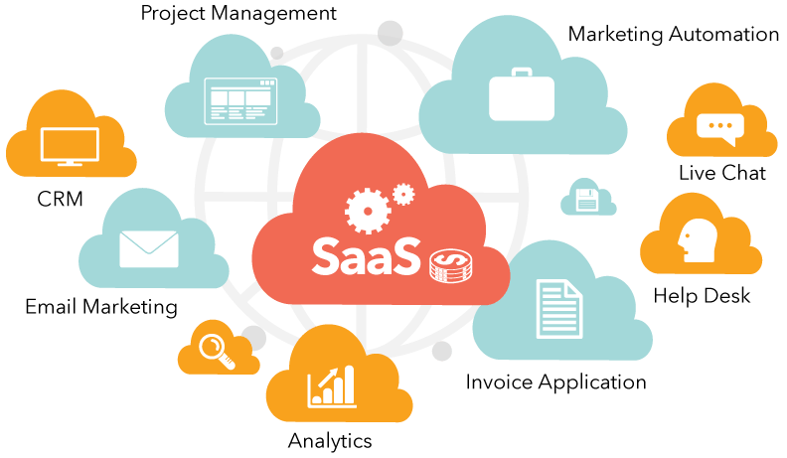

SaaS is also known as "On-Demand Software". It is a software distribution model in which services are hosted by a cloud service provider. These services are available to end-users over the internet so, the end-users do not need to install any software on their devices to access these services.

There are the following services provided by SaaS providers -

* Business Services - SaaS Provider provides various business services to start-up the business. The SaaS business services include ERP (Enterprise Resource Planning), CRM (Customer Relationship Management), billing, and sales.
* Document Management - SaaS document management is a software application offered by a third party (SaaS providers) to create, manage, and track electronic documents.Example: Slack, Samepage, Box, and Zoho Forms.

1. Advantages and Limitation of SaaS

*Advantages*

* Easily Deployable- The ease of access and implementation of SaaS is one of the things that fascinate decision-makers. SaaS solutions are pre-existing, the deployment time is extremely low. In addition, they are generally very flexible and therefore make it possible to stick as closely as possible to user needs and to implement solutions on demand.
* Cost Reduction- The use of a SaaS allows the reduction of costs with servers, which in addition to the cost still requires hours of maintenance and care by your IT staff.The exchange of the physical infrastructure required to maintain a product for a cloud service, whether public or private, saves physical space in addition to financial savings.
* High Scalability- SaaS allows you to multiply access according to the needs of the business rather than investing in software licenses and server capacities internally.The pay-as-you-go model allows organizations to transfer costs to an ongoing operating expense to facilitate budget management

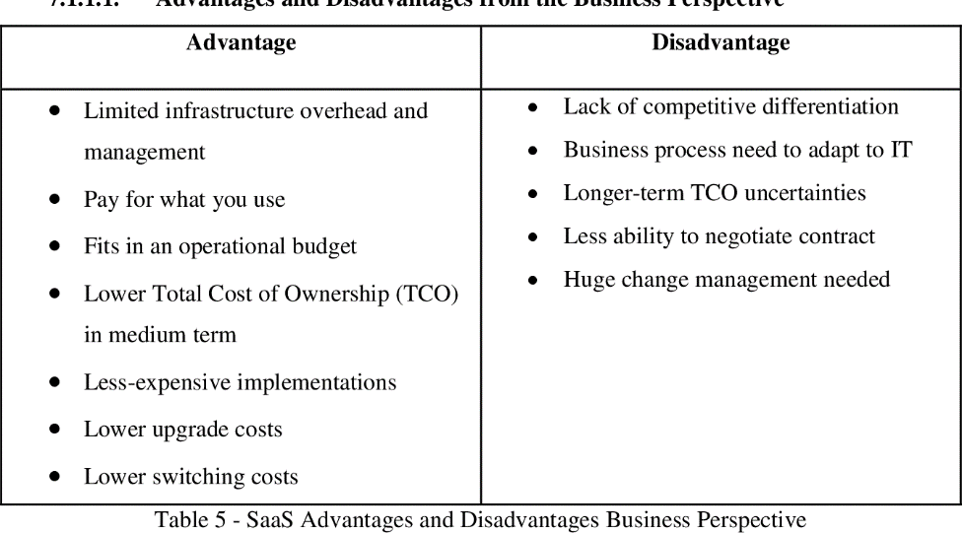

*Disadvantages*

* Confidentiality- The data related to the client company is generally kept on the provider’s servers, which can, therefore, generate confidentiality concerns.The risk of having your data exposed to a public network is one of the key disadvantages, especially when dealing with more traditional corporations.To prevent this, it is necessary to know the accounts that cloud technology provides and make a prior agreement with the service provider listing everything that could happen in the event of disasters.
* Stability- SaaS is an online service that inevitably requires a good internet connection. Hence connectivity is a con as you always need to have a stable internet connection for the system to work in a complete way.Network problems can cause very annoying download delays, which can lead to loss of productivity.

1. Study security issues in cloud computing

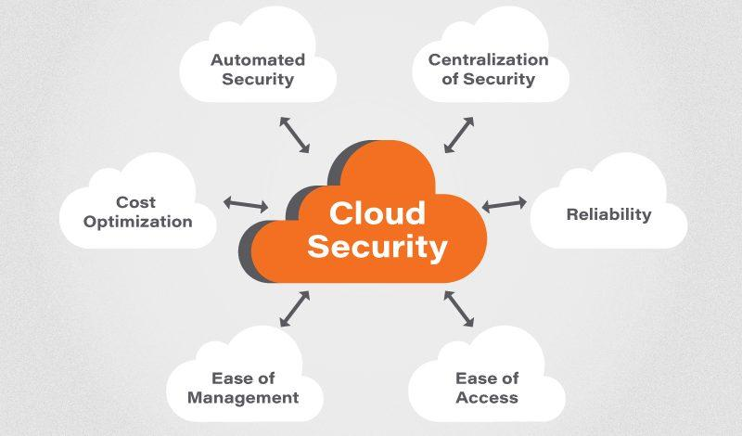

* Responsibility ambiguity- Cloud service users consume delivered resources through service models. The customer-built IT system thus relies on the services. The lack of a clear definition of responsibility among cloud service users and Providers may evoke conceptual conflicts. Moreover, any contractual inconsistency of provided services could induce anomaly, or incidents. However the problem of which entity is the data controller which on is the data processor stays open at an international scale (even if the international aspect is reduced to a minimal third party outside of the specific region like EU).
* Loss of Governance- For an enterprise, migrating a part of its own IT system to a cloud infrastructure implies to partially give control to the cloud service providers. This loss of governance depends on the cloud service models. For instance, IaaS only delegates hardware and network management to the provider, while SaaS also delegates OS, application, and service integration in order to provide a turnkey service to the cloud service user.
* Loss of Trust- It is sometime difficult for a cloud service user to recognize his providers trust level due to the black-box feature of the cloud service. There is no measure how to get and share the providers security level in formalized manner. Furthermore, the cloud service users have no abilities to evaluate security implementation level achieved by the provider. Such a lack of sharing security level in view of cloud service provider will become a serious security threat in use of cloud services for cloud service users.

**Activity:**

## With the help of any suitable cloud service explain SaaS

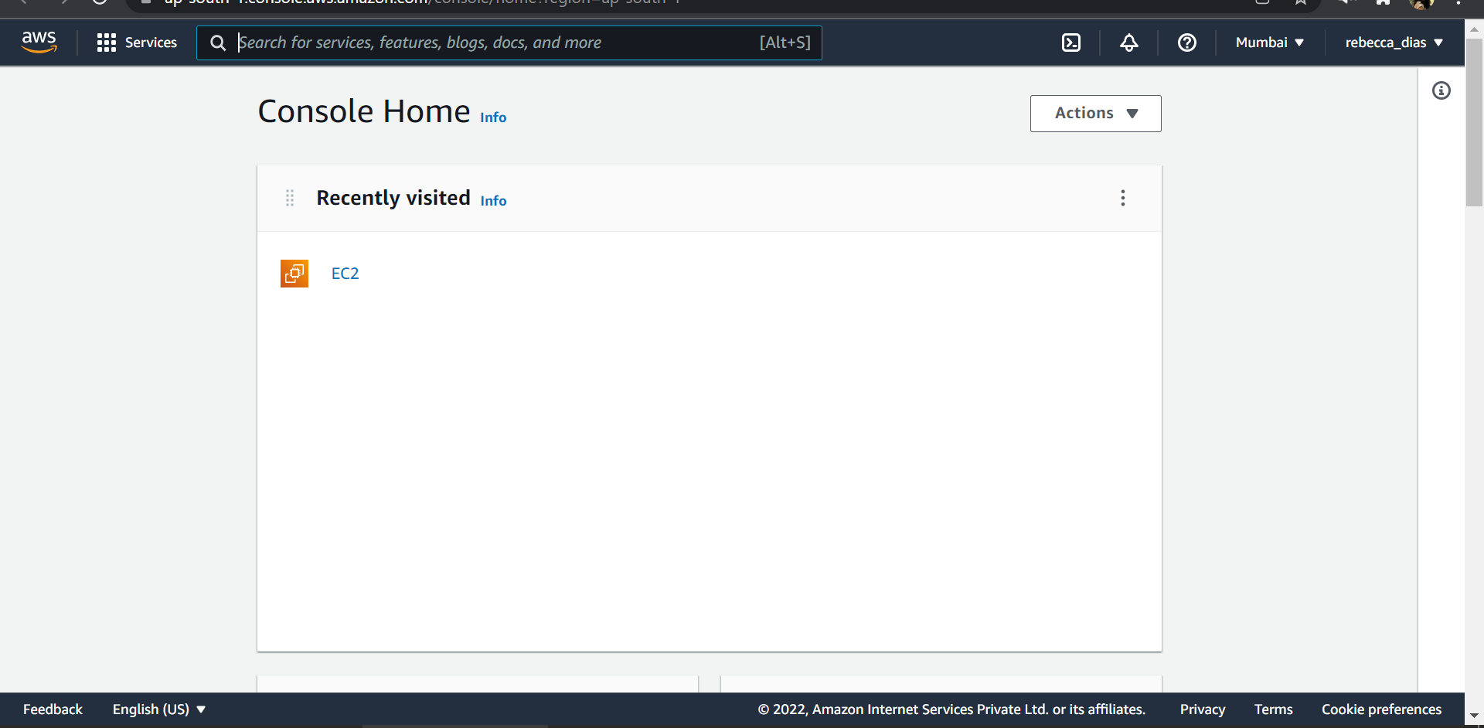

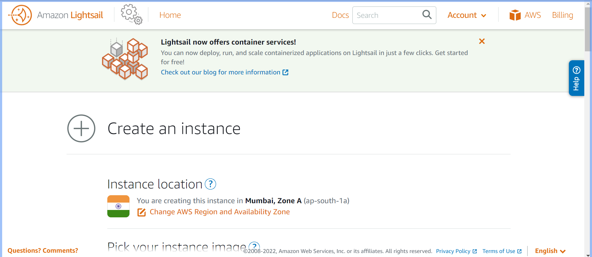

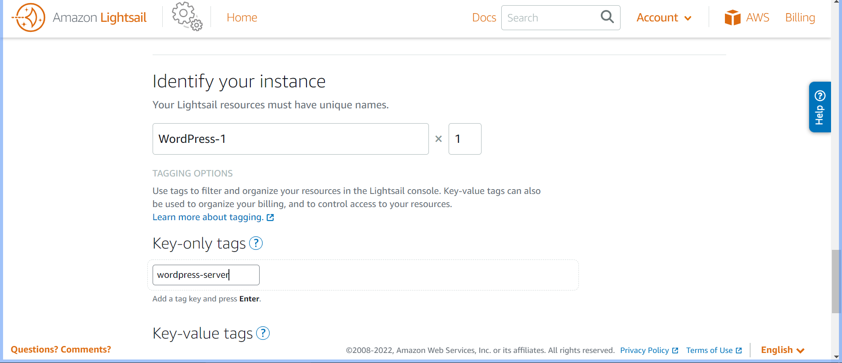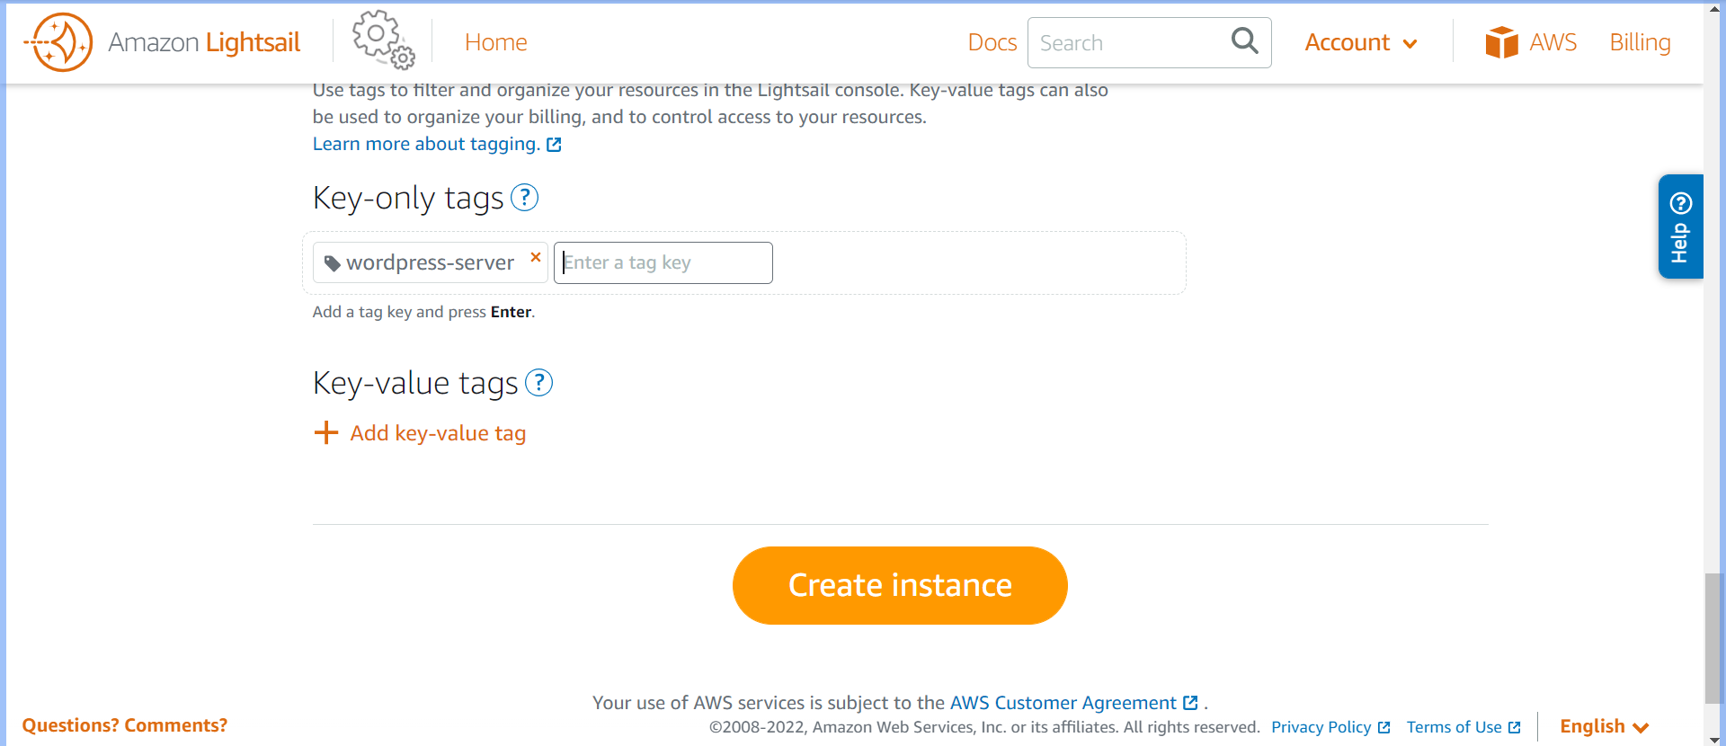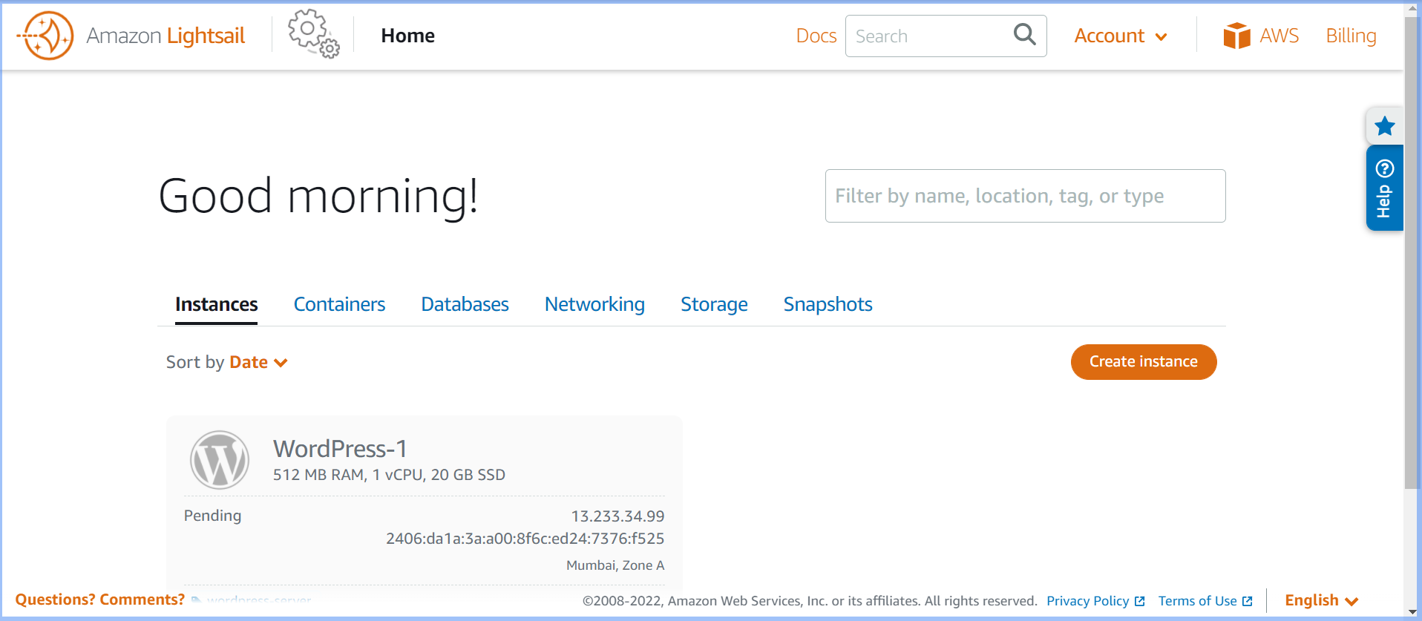**s**

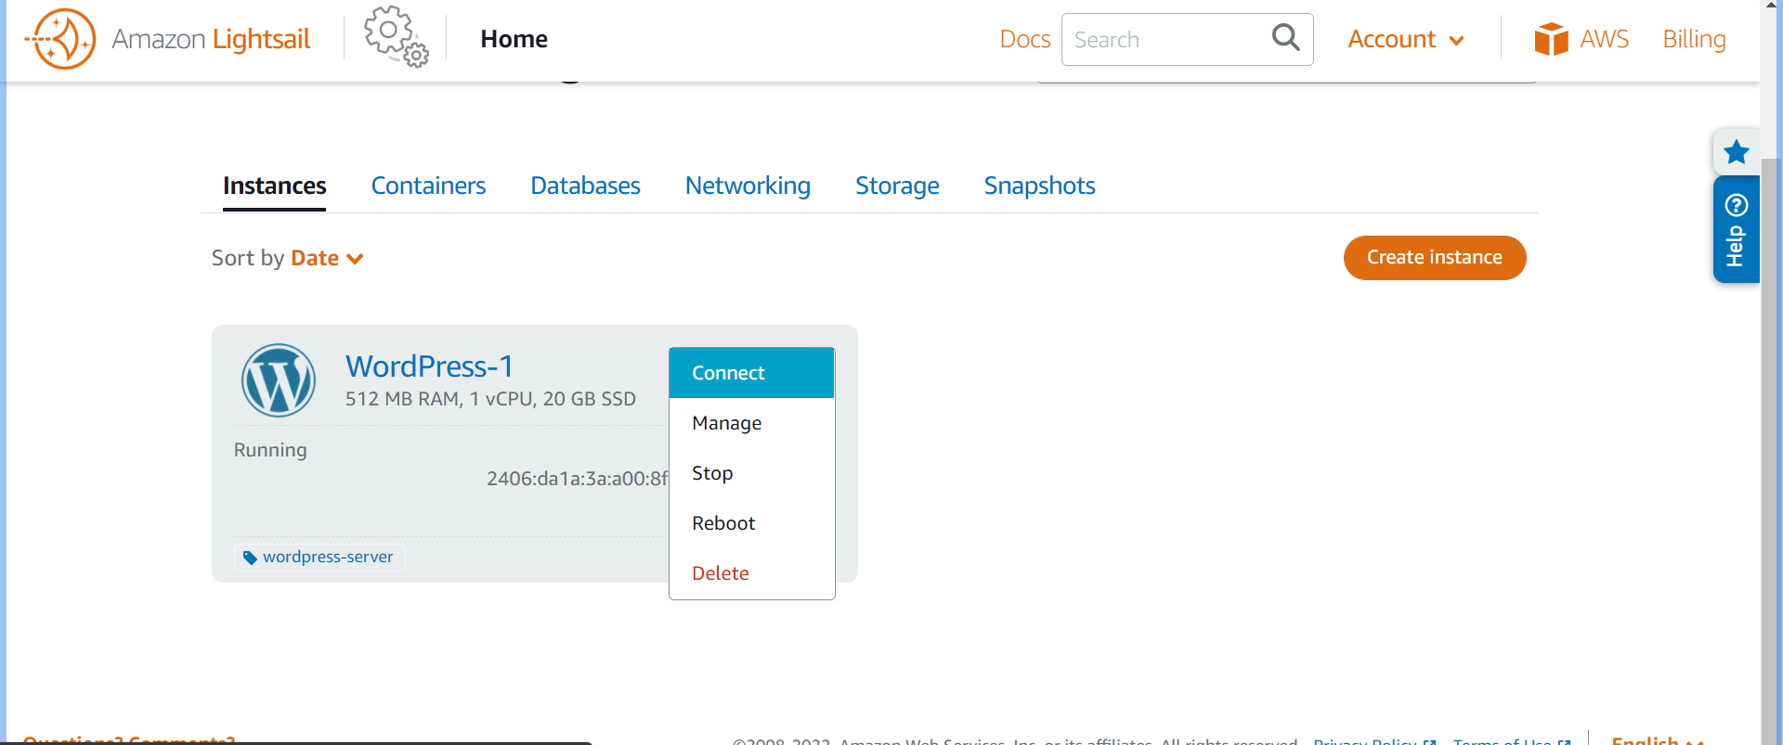

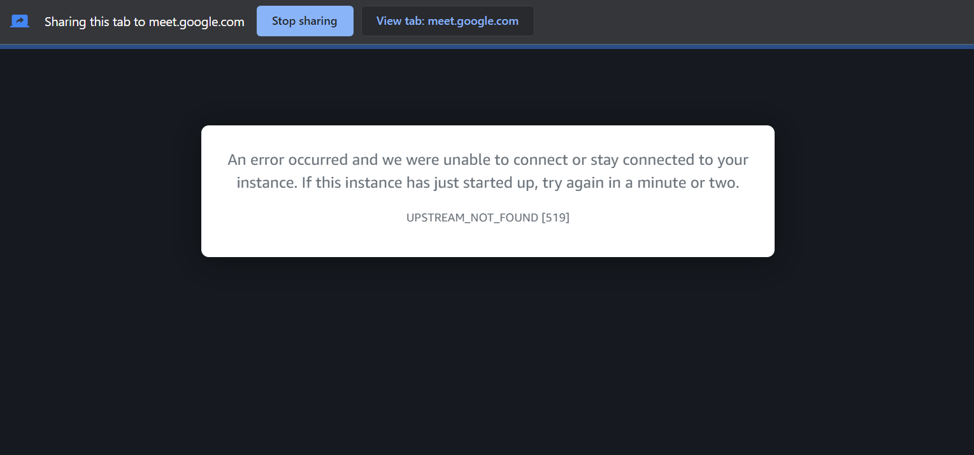

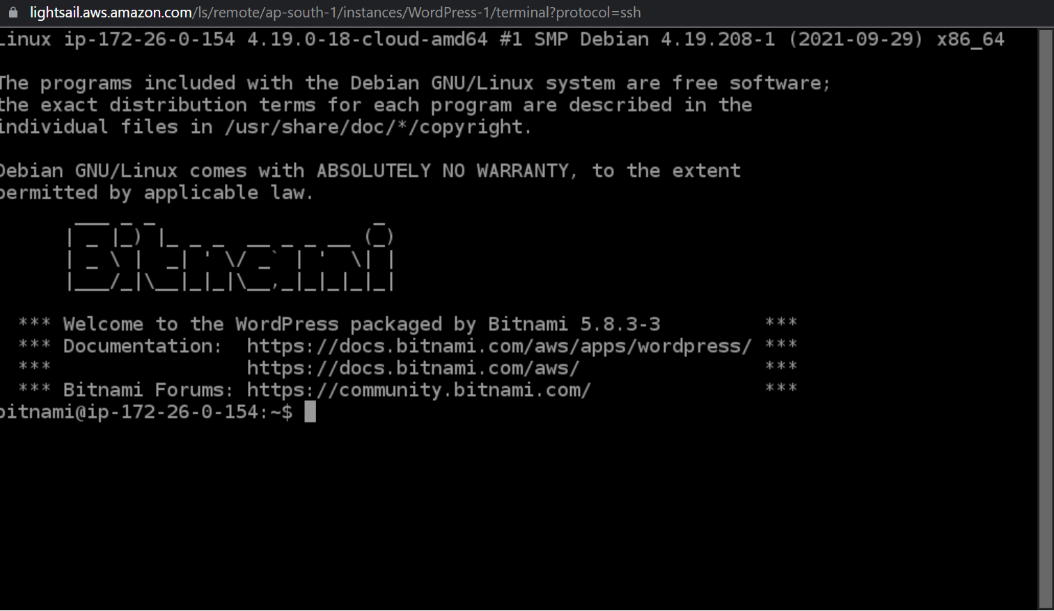

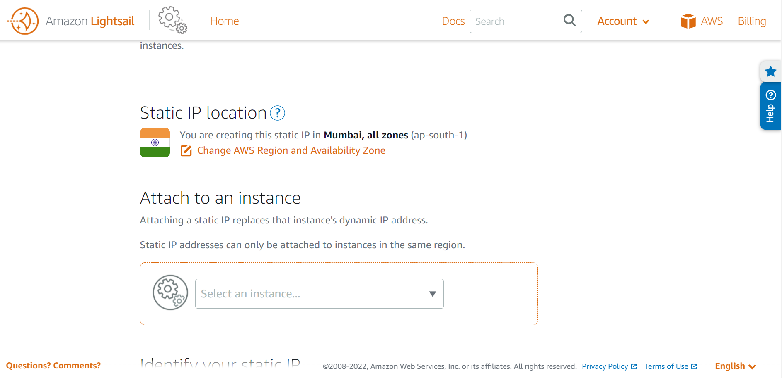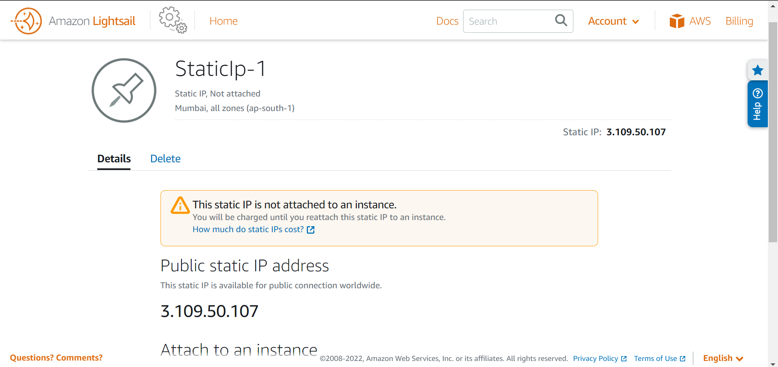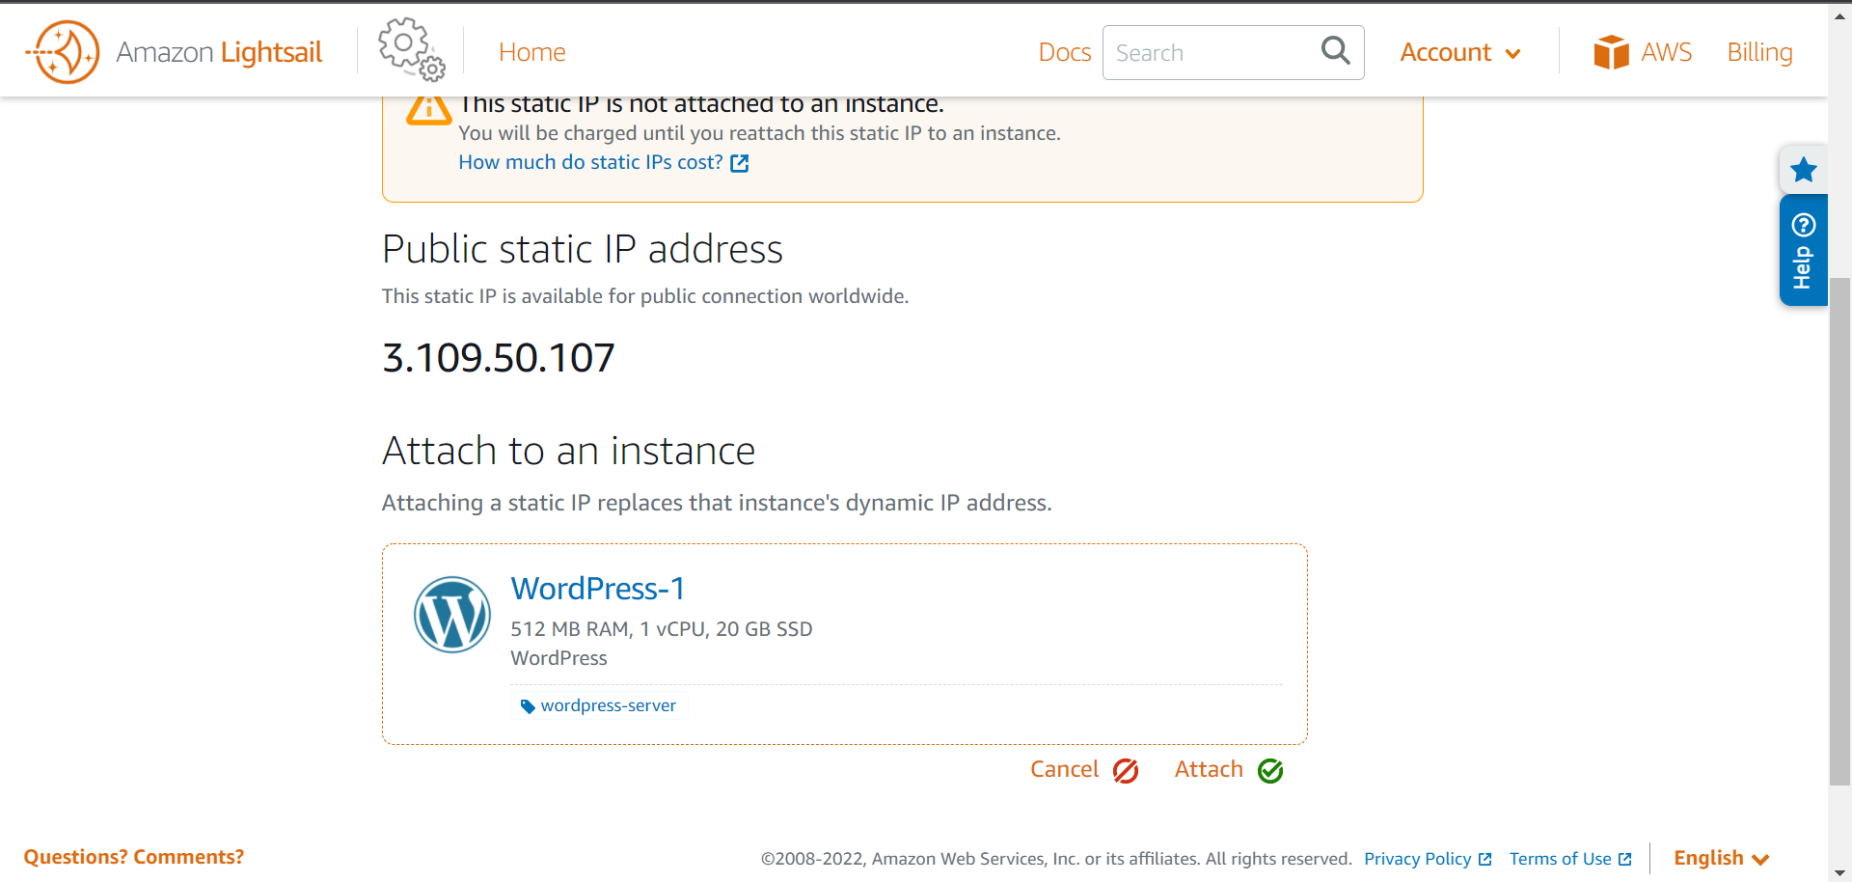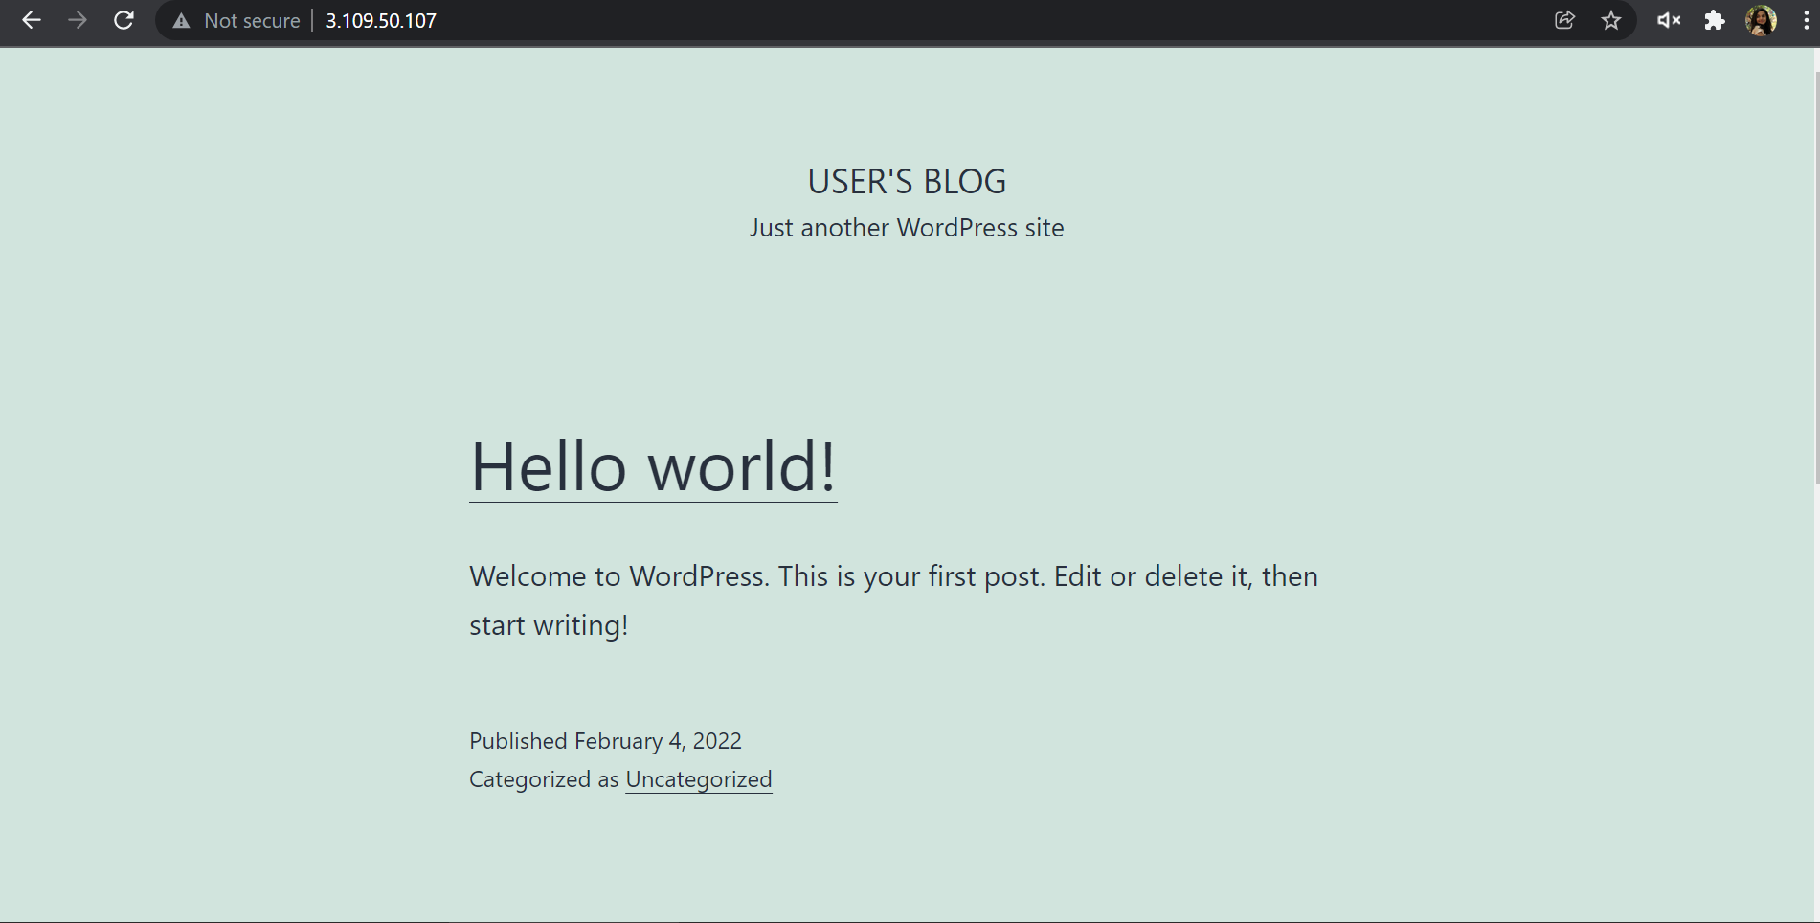

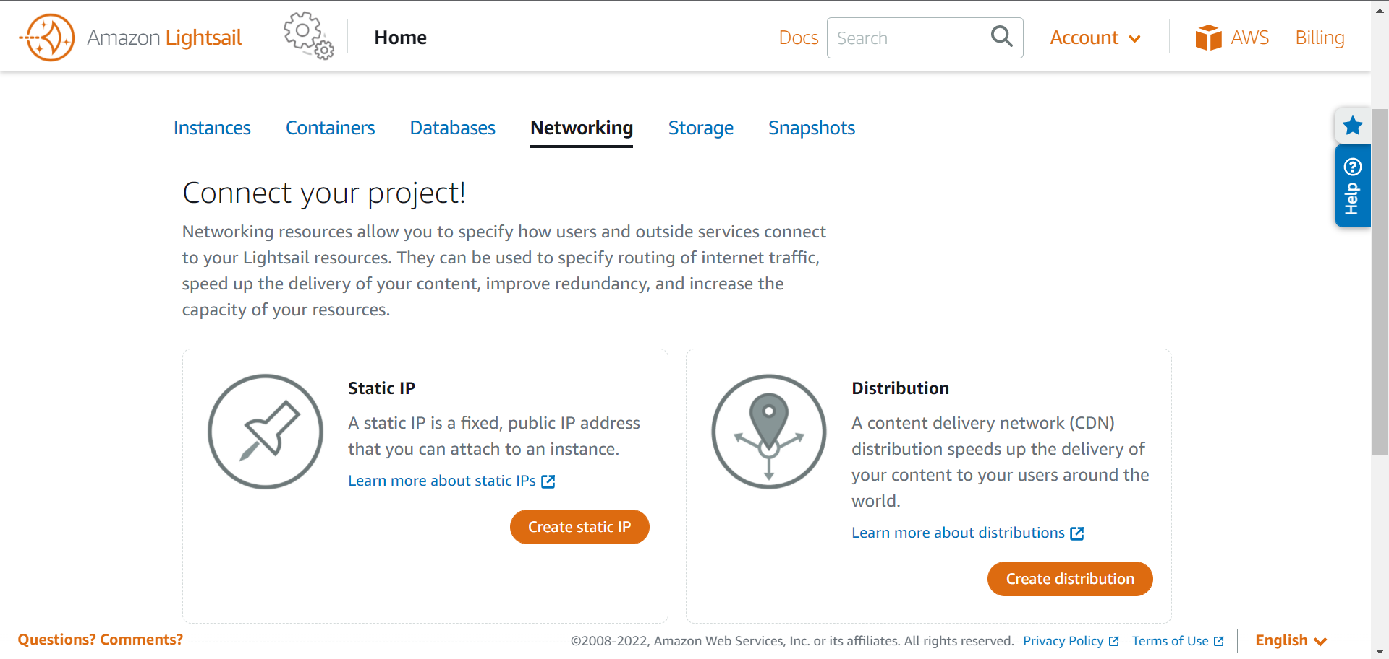

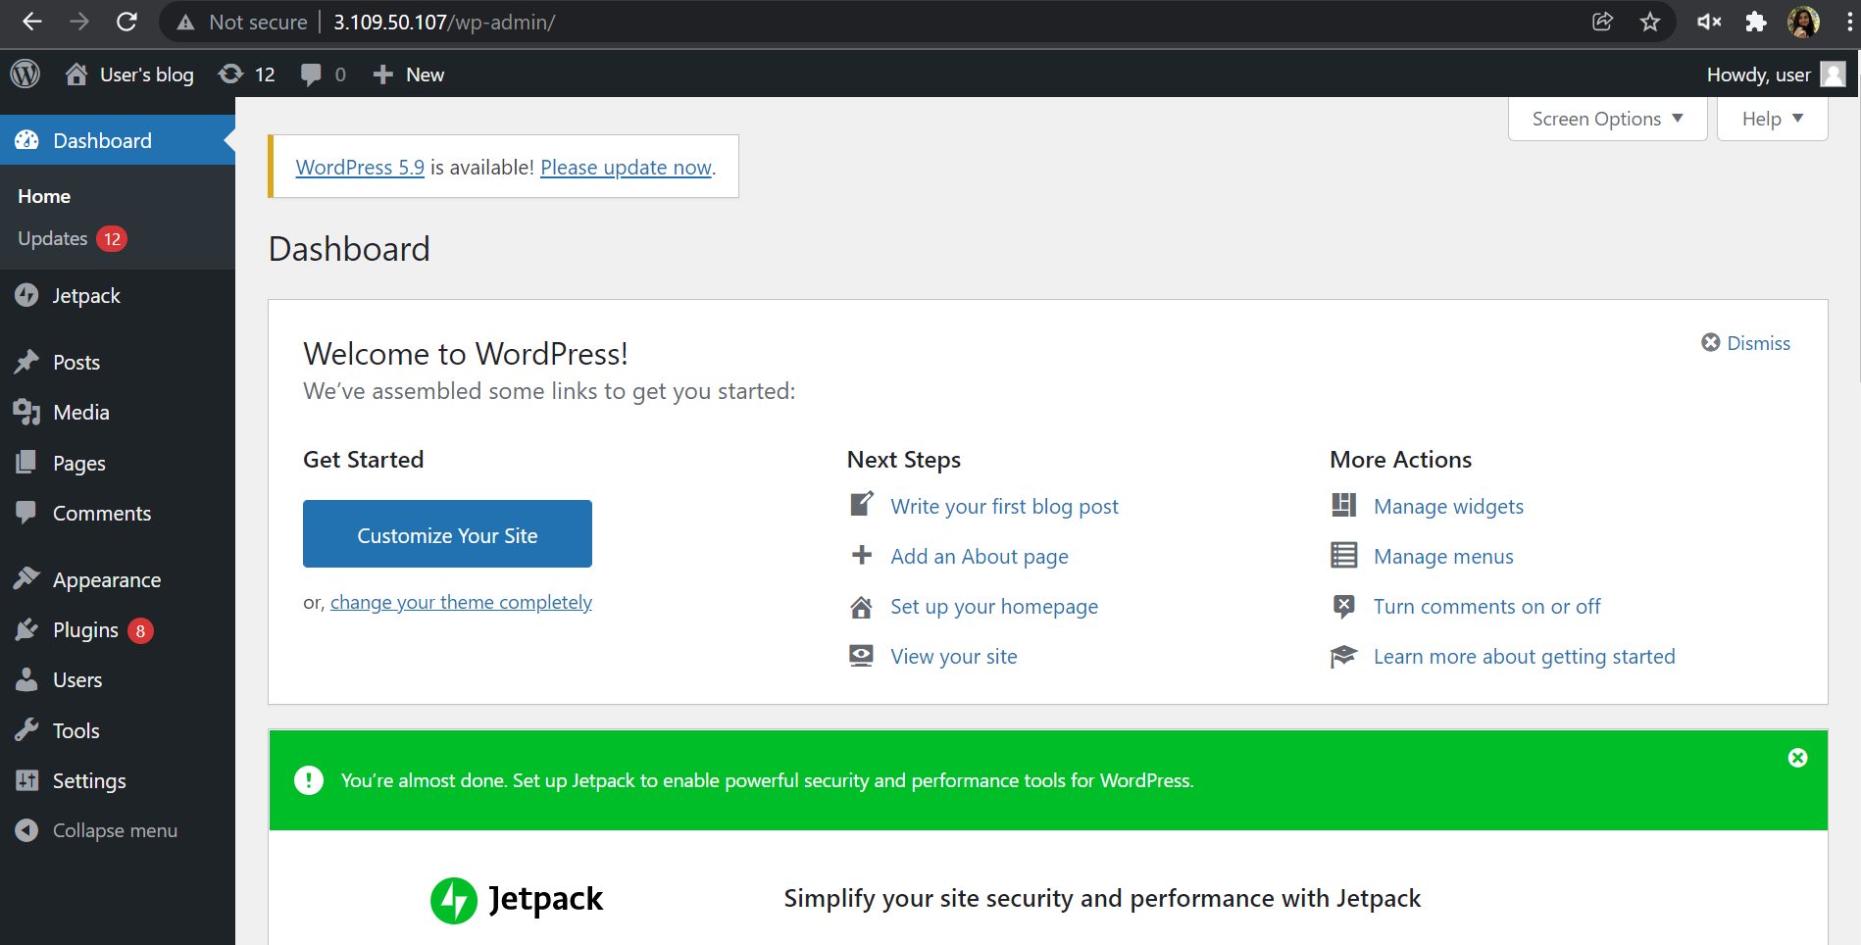

**Conclusion:**

## **Why is SaaS required?**

1. Cost

SaaS can provide notable savings for several different reasons. Foremost, it eliminates the upfront cost of purchase/installation, as well on-going costs like maintenance and upgrades. Instead of spending large amounts of money on hardware installations, SaaS applications can be easily downloaded and maintained.

2. Time

Many people say “time is money” and thankfully, SaaS can save both. For many SaaS applications, installation is as simple as having an internet connection and acquiring a log-in. Furthermore, maintenance responsibilities are shifted from your IT department to the vendor itself. This eliminates extra work hours and downtime that might have been necessary to upgrade conventional software.

3. Scalability & Accessibility

Another great feature of SaaS is that the pay-as-you-go model provides fantastic flexibility and options. Because the software is hosted externally by a vendor, changing your usage plan is easy and can be done without advance notice. Additionally, web-based use allows subscribers to access the software easily from any location with internet capabilities.

**Why cloud computing security is important?**

Security in cloud computing is crucial to any company looking to keep its applications and data protected from bad actors. Maintaining a strong cloud security posture helps organizations achieve the now widely recognized benefits of cloud computing.

1. Lower upfront costs

One of the biggest advantages of using cloud computing is that you don't need to pay for dedicated hardware. Not having to invest in dedicated hardware helps you initially save a significant amount of money and can also help you upgrade your security. This helps you save on costs and reduce the risks associated with having to hire an internal security team to safeguard dedicated hardware.

2. Reduced ongoing operational and administrative expenses

Cloud security can also lower your ongoing administrative and operational expenses. A CSP will handle all your security needs for you, removing the need to pay for staff to provide manual security updates and configurations. You can also enjoy greater security, as the CSP will have expert staff able to handle any of your security issues for you.

3. Increased reliability and availability

You need a secure way to immediately access your data. Cloud security ensures your data and applications are readily available to authorized users. There will always be a reliable method to access your cloud applications and information, helping you quickly take action on any potential security issues.

**References:**

[Software-as-a-Service (SaaS)](https://www.investopedia.com/terms/s/software-as-a-service-saas.asp)

[Software as a Service | SAAS - javatpoint](https://www.javatpoint.com/software-as-a-service)

[What are the Advantages and Disadvantages of SaaS?](https://wisdomplexus.com/blogs/advantages-disadvantages-saas/)

<https://www.ijert.org/an-empirical-study-on-security-issues-in-cloud-computing-environments>